Practical-2 NoSQL

1. Installing Mongo shell.

Download MongoChef by using link: https://studio3t.com/download-thank- you/?OS=win64

After completion of installation of MongoChef, when you launch it, it’s first interface looks like as below.

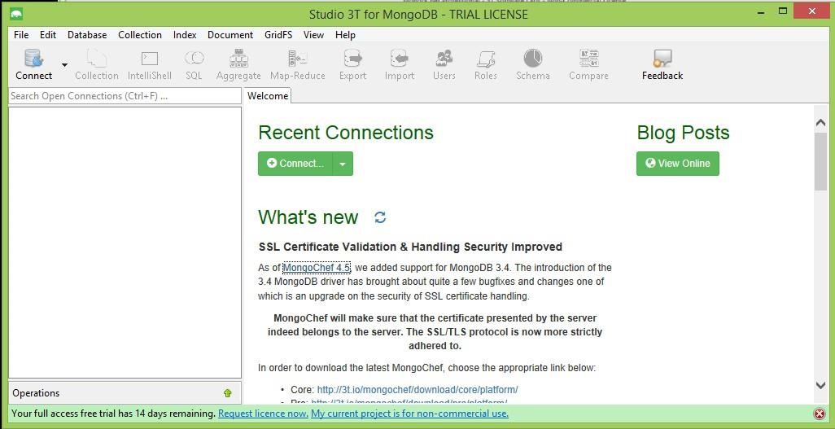

Open terminal and execute mongod.exe command, to make background daemon wait to establish connection.

Set path of MongoDB in environment variable as:

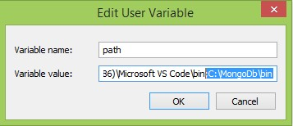

Practical-2 NoSQL

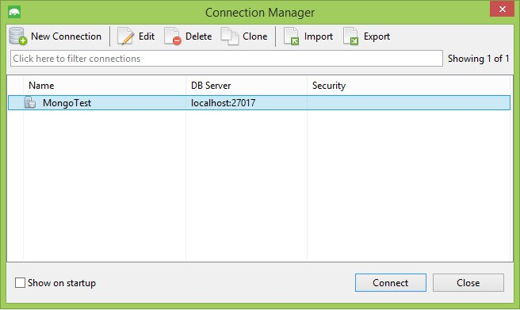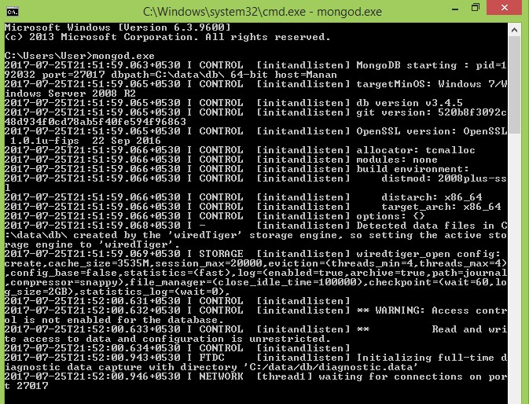

In MongoChef click on Connect, then click on New Connection. Give name of connection and click on save.

Select your connection and click on connect.

It will display all the collections under connection.

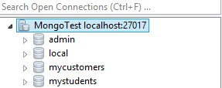

Click on IntelliShell. In that shell we can execute our executable statement or script.

# COMMANDS

1. **CREATE USER**

**db.createUser({ user: "Patel",**

**pwd: "123",**

**roles:[{role: "userAdminAnyDatabase" , db:"admin"}]**

**})**

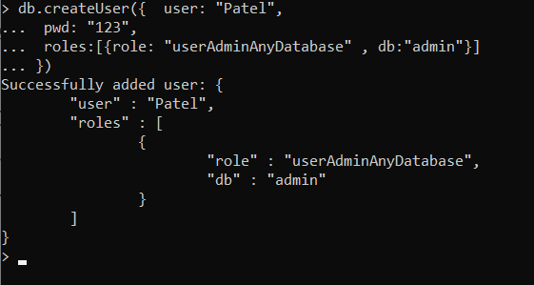

1. **CREATE DATABASE**

**Use emp**

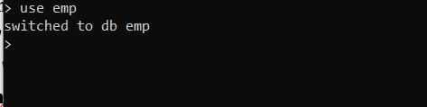

1. **CREATE COLLECTION**

**db.createCollection("emp")**

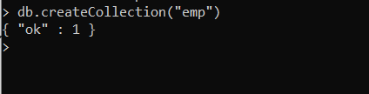

1. **INSERT DATA INTO DATABASE**

o **db.emp.insert( {"empid" : 1, "empnam" : "Dhoni"})**

o **db.emp.insert( {"empid" : 2, "empname" : "Kholi"})**

o **db.emp.insert( {"empid" : 3, "empname" : "Sachin" , "age" : 23})**

o **var myemp=[ {"empid" : 4, "empname" : "smith"}, {"empid" :**

**4,"empname" : "john"} ];**

**db.emp.insert(myemp)**

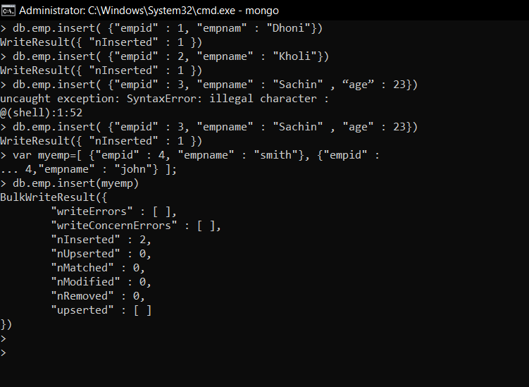

1. **UPDATE AND DELETE DATA** 
   * **db.emp.update({"empid" :1},{$set:{"empname" : "Patel"}})** • **db.emp.update({"empid" :1},{$set:{age:50})**

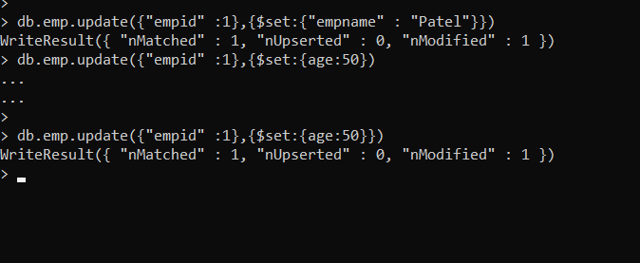

* + • **remove particular field:**
  + **db.emp.update({"empid" :1},{$unset:{age:40})**
  + **update value of age by 5:**

**db.emp.update({"empid" :1},{$inc:{age:5})**

* + **removing whole document db.emp.remove({empid:3})**
  + **If no document matching with particular condition exists, then if we set upsert “true”, then initially it will also create it.**

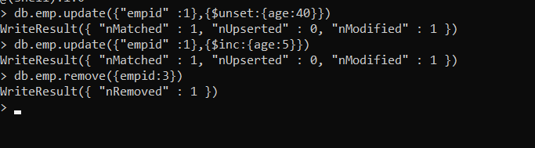

**db.emp.update({empid:3},{empid:5,empname:"Patel"},{upsert:true**

**});**

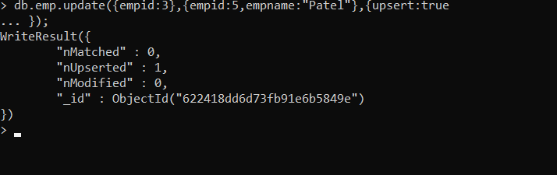

* + **Renaming any particular field db.emp.update({empid:4},{$rename:{"empname":"nameemp"}});**

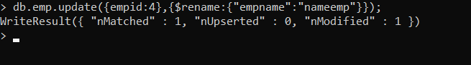

1. **RETRIVAL OF DATA** 
   * **db.emp.find().forEach(printjson)**

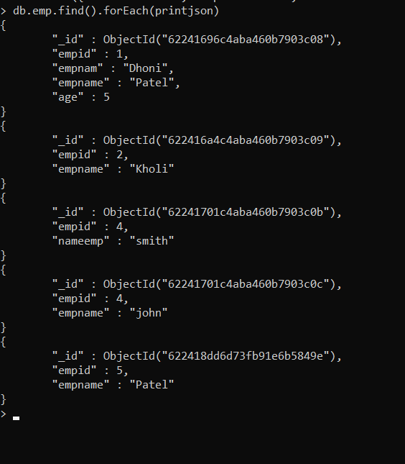

* + **db.emp.find().pretty()**

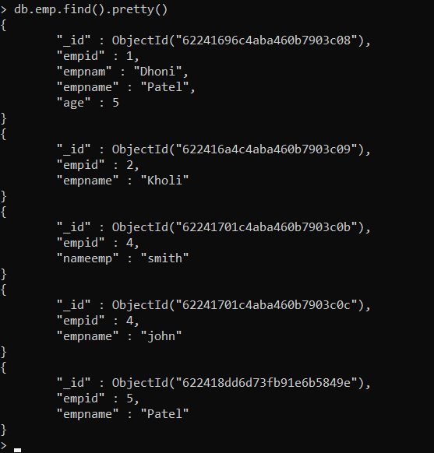

* + **db.emp.find( { } )**
  + **db.emp.find({empname : "smith"} ).forEach(printjson)**

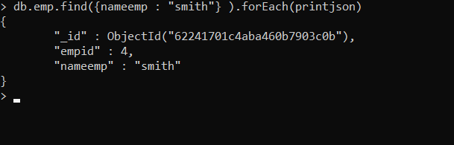

* + **db.emp.find({empid : {$gt:2}})**

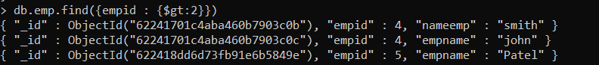

**var myemp=db.emp.find( { empid : {$gt:2}}) while(myemp.hasNext()){ print(tojson(myemp.next()));**

**}**

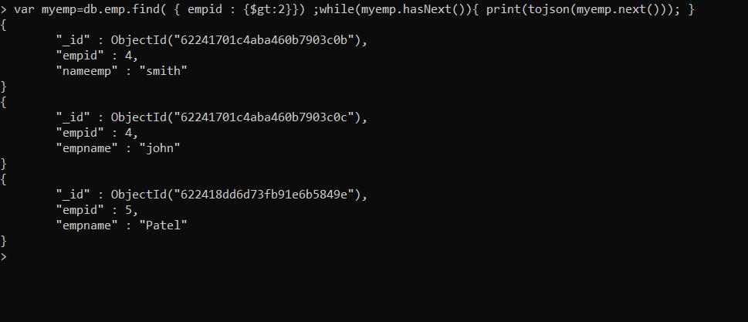

1. **DISPLAY DATABASE show dbs**

